**Practical No 4**

**Aim: To Study Of Activity Diagram**

**Activity Diagram:**

Activity diagram is another important behavioral diagram in [UML](https://en.wikipedia.org/wiki/Unified_Modeling_Language) diagram to describe dynamic aspects of the system. Activity diagram is essentially an advanced version of flow chart that modeling the flow from one activity to another activity.We use Activity Diagrams to illustrate the flow of control in a system and refer to the steps involved in the execution of a use case. We model sequential and concurrent activities using activity diagrams. So, we basically depict workflows visually using an activity diagram. An activity diagram focuses on condition of flow and the sequence in which it happens. We describe or depict what causes a particular event using an activity diagram. UML models basically three types of diagrams, namely, structure diagrams, interaction diagrams, and behavior diagrams. An activity diagram is a behavioral diagram i.e. it depicts the behavior of a system. An activity diagram portrays the control flow from a start point to a finish point showing the various decision paths that exist while the activity is being executed. We can depict both sequential processing and concurrent processing of activities using an activity diagram. They are used in business and process modelling where their primary use is to depict the dynamic aspects of a system. An activity diagram is very similar to a flowchart.

**When to Use Activity Diagram:**

1. Identify candidate use cases, through the examination of business workflows
2. Identify pre- and post-conditions (the context) for use cases
3. Model workflows between/within use cases
4. Model complex workflows in operations on objects
5. Model in detail complex activities in a high-level activity Diagram

**Notations In Activity Diagram Are:**

* **Activity**
* **Action**
* **Control Flow**
* **Object Flow**
* **Initial Node**
* **Activity Final Node**
* **Object Node**
* **Decision Node**
* **Merge Node**
* **Fork Node**
* **Join Node**
* **Swimlane and Partition**

**A. Create an activity diagram describing the process of a person (user)**

**using the machine to buy a ticket from Churchgate to Virar. The machine**

**accepts only coins (no credit cards, debit cards).**

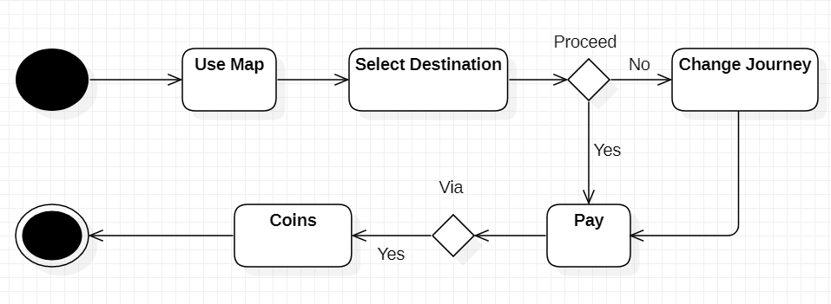

**B. Draw a detailed activity diagram for following scenario:**

**A product is to be installed to control elevators in a building with m**

**floors. The problem concerns the logic required to move elevator**

**between floors according to the following constraints. Each elevator has**

**a set of m Buttons, one for each floor. These illuminate when pressed and**

**cause the elevator to visit the corresponding floor. The illumination is**

**cancelled when the elevator visits the corresponding floor. Each floor,**

**except the first floor and top floor has two buttons, one to request and up**

**elevator and one two request a down elevator. These buttons illuminate**

**when pressed. The illumination is cancelled when an elevator visits the**

**floor and then moved in the desired direction.**

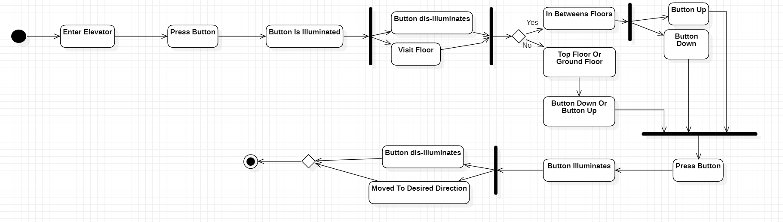

**C. A customer decides to upgrade her PC and purchase a DVD player. She**

**begins by calling the sales department of PC vendor and they tell her to**

**contact customer support. She than calls customer support and they put**

**her on hold while talking to engineering. Finally, customer support tells**

**the customer about several supported DVD options. The customer**

**chooses a DVD and it is shipped by the mail department. The customer**

**receives the DVD, installs it satisfactorily and then mails her payment to**

**accounts department. Draw the activity diagram for above description.**

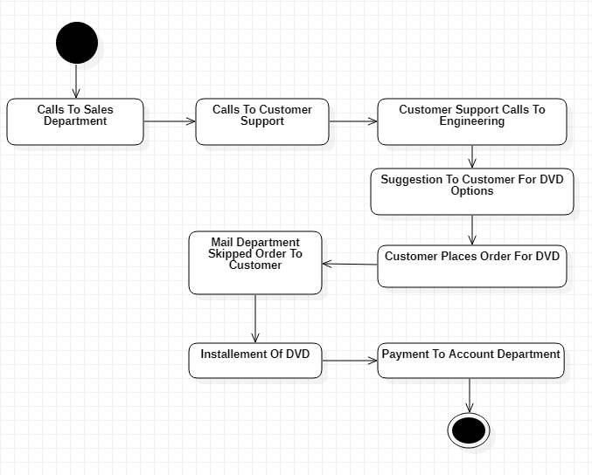

**Conclusion: We have studied the details about the activity diagram.**